UB MBA INTERVIEW EVENT – ULTIMATE INTERVIEW CHALLENGE
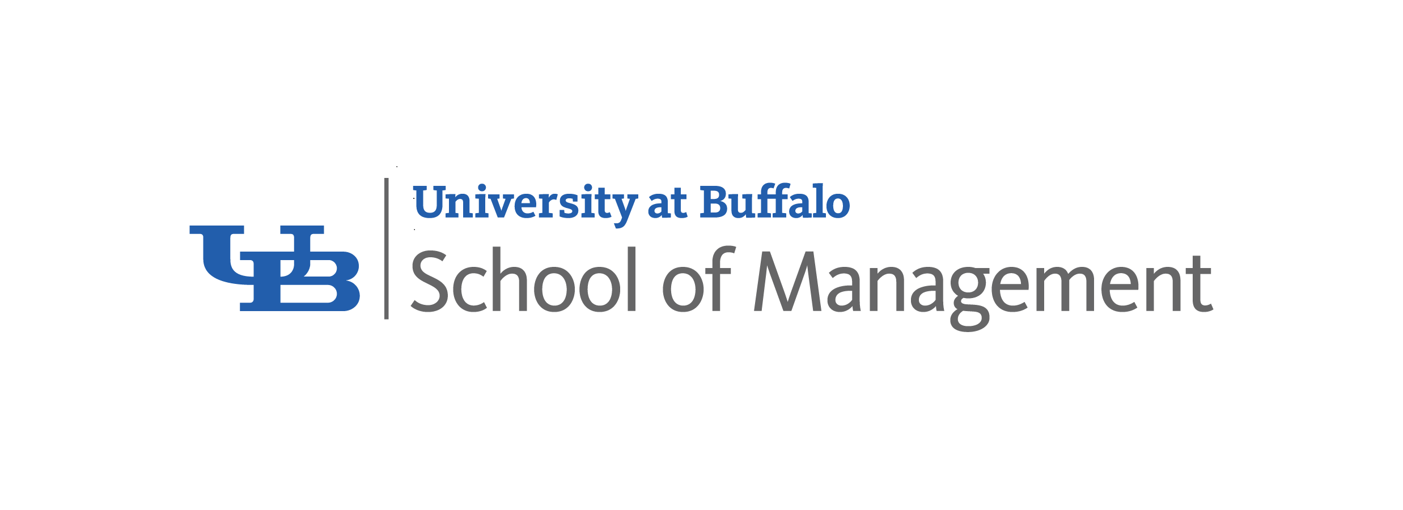

INTERVIEW QUESTIONS

Format: 25-30 min. interview / 15-20 min. feedback / 15 min. evaluation
Please act as representative from the company on the posting (not your own).

- Can you tell me a little about yourself?

- What do you know about our company? Why are you interested in this position at _____________________?

Questions 3, 4, and 5 -- PLEASE SELECT 3 QUESTIONS FROM BELOW TO ASK
- Describe a situation where you had to manage multiple priorities in a work or internship setting.
- Tell me about a time when you persuaded someone to use your idea or accept your point of view.
- Tell me about a time you identified a problem or need for improvement and made a recommendation about it.
- Collaboration is so important in today’s workplace. Can you tell me about a time when you adapted your style to work more effectively with others?
- Give me an example of a team project: What was your role? What did you personally contribute? What did the team accomplish?
- Tell me about a time in your life when you demonstrated leadership or had a significant impact.
- Describe your proudest accomplishment when it comes to taking initiative or seizing an opportunity.
- Describe a project or situation that best demonstrates your analytical abilities. What was your role?
- Describe a time when you had to present complex information. (How did you ensure that the audience understood?)?
- If you could have coffee with anyone living or dead, who would it be?

- Do you have any questions you would like to ask?
[You do NOT need to answer these. Just say, ‘The real company rep/interviewer would answer that…do you have any other questions?’]

- End the interview…so they can close /thank you for your time.

PROVIDE THE STUDENT WITH IMMEDIATE FEEDBACK.
They are welcome to take notes during the feedback portion of the interview.

FINALLY, COMPLETE THE ONLINE EVALUATION.

Thank you!

